Project Design Phase-I
Problem – Solution Fit Template

Date | 27 October 2026
Team ID | Not provided by user
Project Name | Global Olympic Sports Performance Analysis
Maximum Marks | 2 Marks

Problem – Solution Fit Template:
The Problem-Solution Fit simply means that you have found a problem with your customer and that the solution you have realized for it actually solves the customer’s problem. It helps entrepreneurs, marketers and corporate innovators identify behavioral patterns and recognize what would work and why
Purpose:
- Solve complex problems in a way that fits the state of your customers.
- Succeed faster and increase your solution adoption by tapping into existing mediums and channels of behavior.
- Sharpen your communication and marketing strategy with the right triggers and messaging.
- Increase touch-points with your company by finding the right problem-behavior fit and building trust by solving frequent annoyances, or urgent or costly problems.
- Understand the existing situation in order to improve it for your target group.

Template:
Canvas element | Global Olympic Sports Performance Analysis
Customer segment(s) | Data analytics students, sports researchers, sports administrators and viewers comparing Olympic performance.
Jobs-to-be-done / problems | Compare country medal totals/ranks; review changes over time; compare sport categories and regions; understand context before drawing conclusions.
Emotions before / after | Before: overloaded by raw tables and unsure which measure to compare. After: more confident exploring patterns, provided definitions and limits are visible.
Triggers | A class assignment, research question, sports performance review or need to explain country/region patterns.
Customer constraints | Limited time, incomplete source provenance, different Olympic event counts, unfamiliarity with Tableau, and uncertainty about metric definitions.
Available solutions | Manual spreadsheets, static rankings, raw data tables, news articles and separate charts; each may cover only part of the question.
Behaviour | Open the workbook, inspect rankings and trends, use available filters, compare charts and prepare a summary.
Online channels | Packaged Tableau workbook; Tableau Public could be used after publication; report and video can be shared as supporting artifacts.
Offline channels | Classroom demonstration, project review, discussion with an instructor or sports-analysis team.
Problem root cause | Related measures are split across datasets/views and simple medal totals can be misread without scope and definition checks.
Your solution | Seven Tableau worksheets arranged in two dashboards using four packaged Hyper extracts, with documented business questions and interpretation caveats.
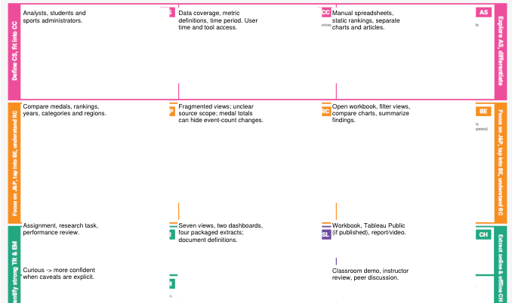
References:
- https://www.ideahackers.network/problem-solution-fit-canvas/
- https://medium.com/@epicantus/problem-solution-fit-canvas-aa3dd59cb4fe

